DBSE&DBD

NAME : G.ROHITH
ROLL NO : 2520030220

Query-1:
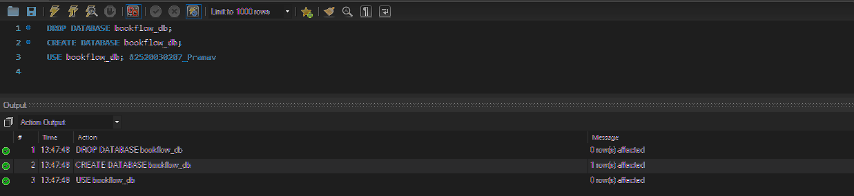
Query-2:

Query-3: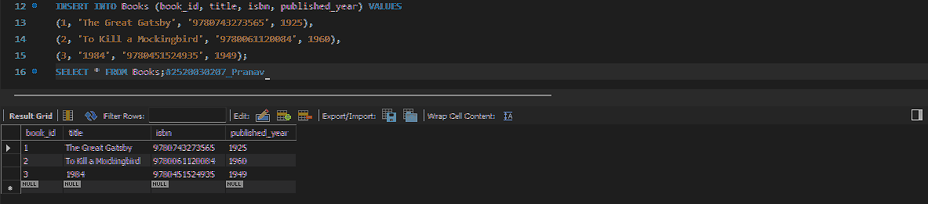
Query-4:


Query-5:
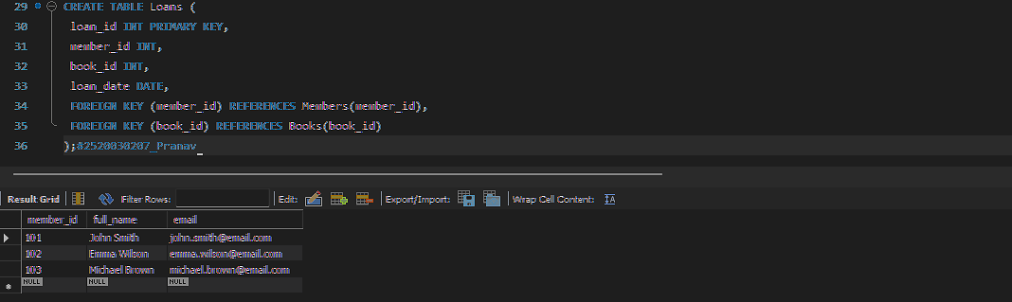

Query-6: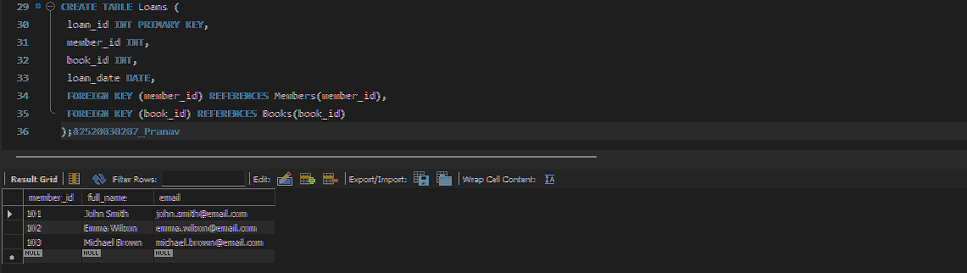
Query-7:
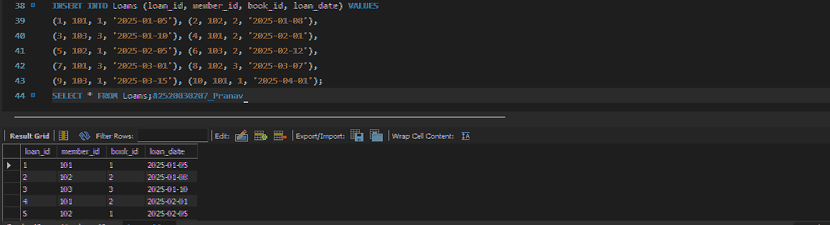

Query-8: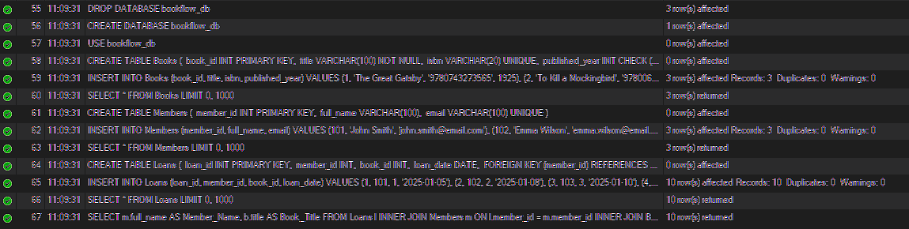

Query-9:
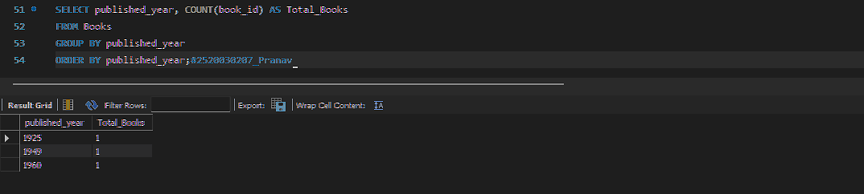
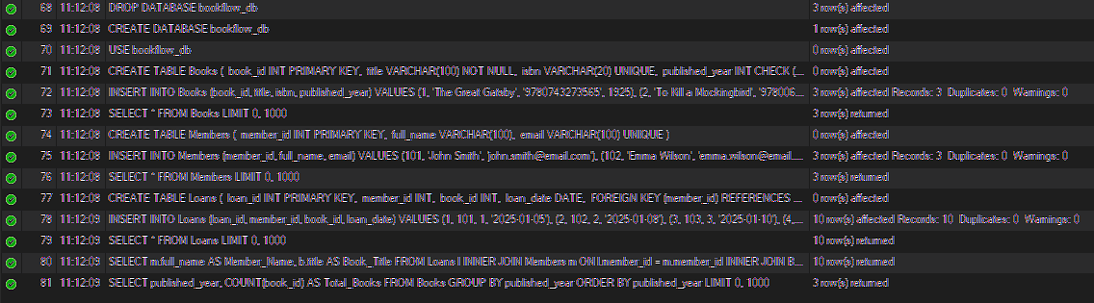

Query-10:
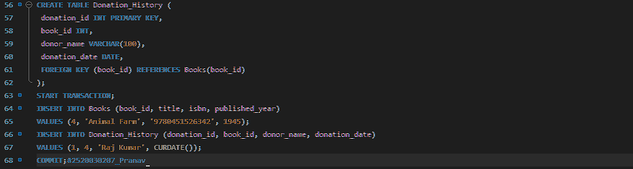
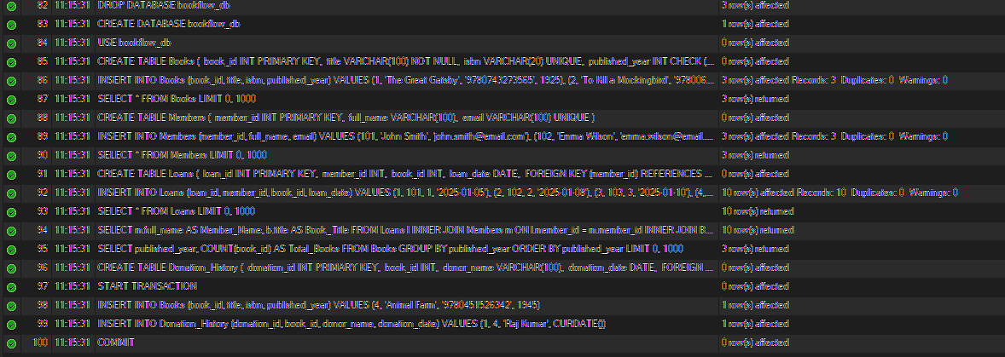
Query-11:

